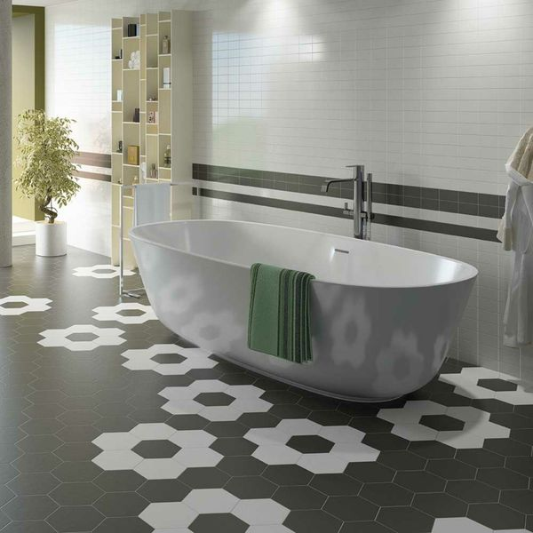**Black Saga Hexagon Tiles:**

## **Product Description**

Create a dark and contemporary look in your interiors with the simple addition of these Black Saga Tiles. Hexagonal in shape, these six-sided tiles are great for introducing the hexagon decor trend into an interior area. They can be used both indoors and outdoors on either a wall space or a floor space, as they're made from durable porcelain. They belong to our collection of Allegory Hexagon Tiles and have a soft matt finish. For best results, combine with other stylish designs from the same range.

## **Product Info**

* Product ID: 14408
* Tiles Per SQM: 38.490017945975
* Sale by: Per SQM
* Size: 200x175mm
* Weight: 0.53 KG
* Material Type: Porcelain
* Finish: Matt
* Colour: Black/Charcoal
* Suitability: Floors, Walls
* Grade: 4
* Rectified Edge: No
* Underfloor Heating: Yes
* Thickness (mm): 8